Hi ________,

We are Gordon and Terri Brest. We live west of Tonganoxie in the country.
We raise mums for groups to sell as a fundraiser. This is a chance for you to sell something people want to buy and get better than 50% return on your investment.

We offer premium, hardy Belgian mums with five beautiful colors to choose from. Each plant comes in a 9” pot and has a 15-20” crown. Because they are hardy mums they can be planted upon receipt and should come back the following year. Or you can just leave them in their pots. They like sunny locations and love water. Each plant comes with a slow-release fertilizer which will sustain them until the end of the year. Here’s a couple of pictures of mums we shipped out last year.

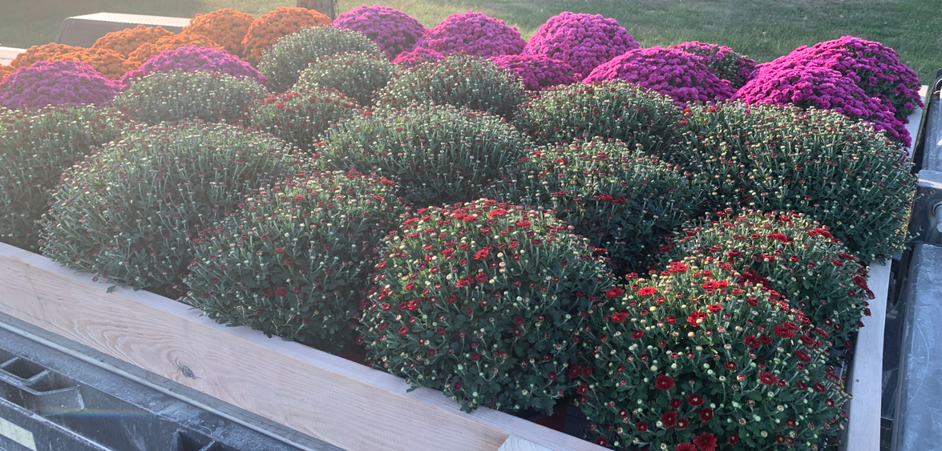

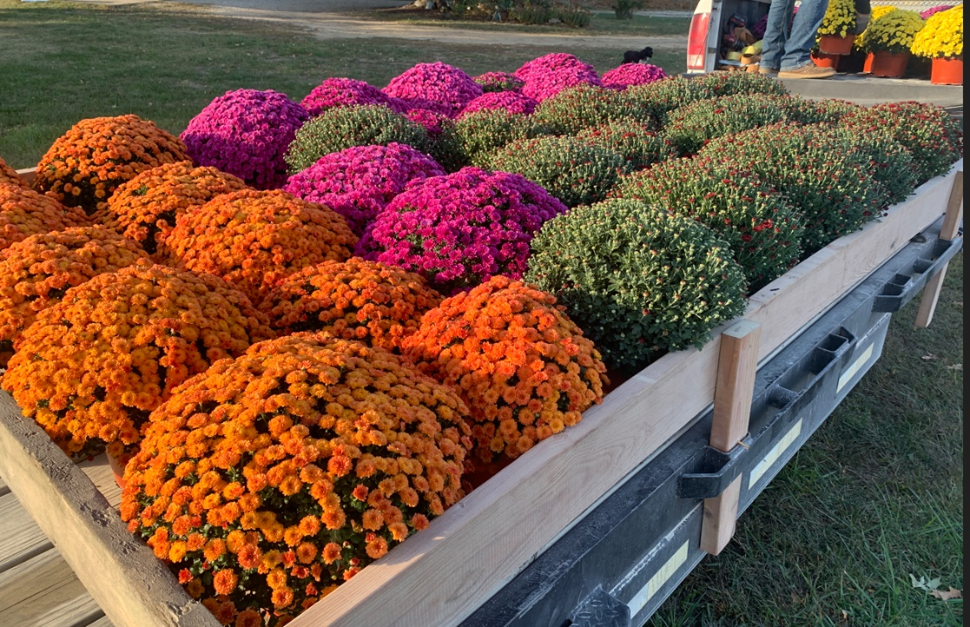

Interested in a great fundraiser? Contact us at any of these email addresses:

gordon.brest@gmail.com
n2stamps@yahoo.com

Here’s the details for getting your fundraiser started:
- The mums are $10 each. We ask for payment at pickup.
- We recommend the mums are sold for at least $25 which is a comparable price for the same mum at any big box store. [Note: The quality and growth on these mums is better than you can find there.]
- We ask for commitments to blocks of 10 mums. However, we will work with small organizations because we want you to be successful. We have groups with only 5 people. We understand. Don’t let this discourage you from taking advantage of this opportunity.
- The mums will be available for pickup at our house west of Tonganoxie, KS. We can provide delivery for 50 mums per trip for a $25 plus $0.50/mile fee from Tonganoxie.
- Only 1,000 mums were grown for 2026. As of this letter, 600 are committed. When they are all committed, we are done selling for the year. Don’t miss out!
- The flyer and order form attached show the colors and names of the mums we are selling.

Visit our websites www.mums4fundraising.com, www.ourmumsgarden.com and follow us on Facebook @ Mum's Garden.

-Gordon & Terri

