MUM FUNDRAISER

(your organization name here)

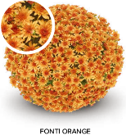
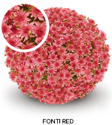
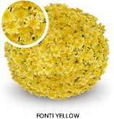
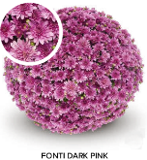

$25 each
_______ will coordinate delivery
the week of September _____
Name | Phone | Fonti Dark Pink | Fonti Orange | Fonti  Red | Fonti Yellow | Total | Paid
Premium Belgian Mum Information:
- Blooms expected mid-September
- 9” mum pots and the crown will range in size from 15”to 20” in diameter.
- These are hardy variety that can be planted and will come back the following year (They need a lot of water and fertilizer to establish roots.)
- $15 comes back to the _________
For Additional questions, please contact _____________________

